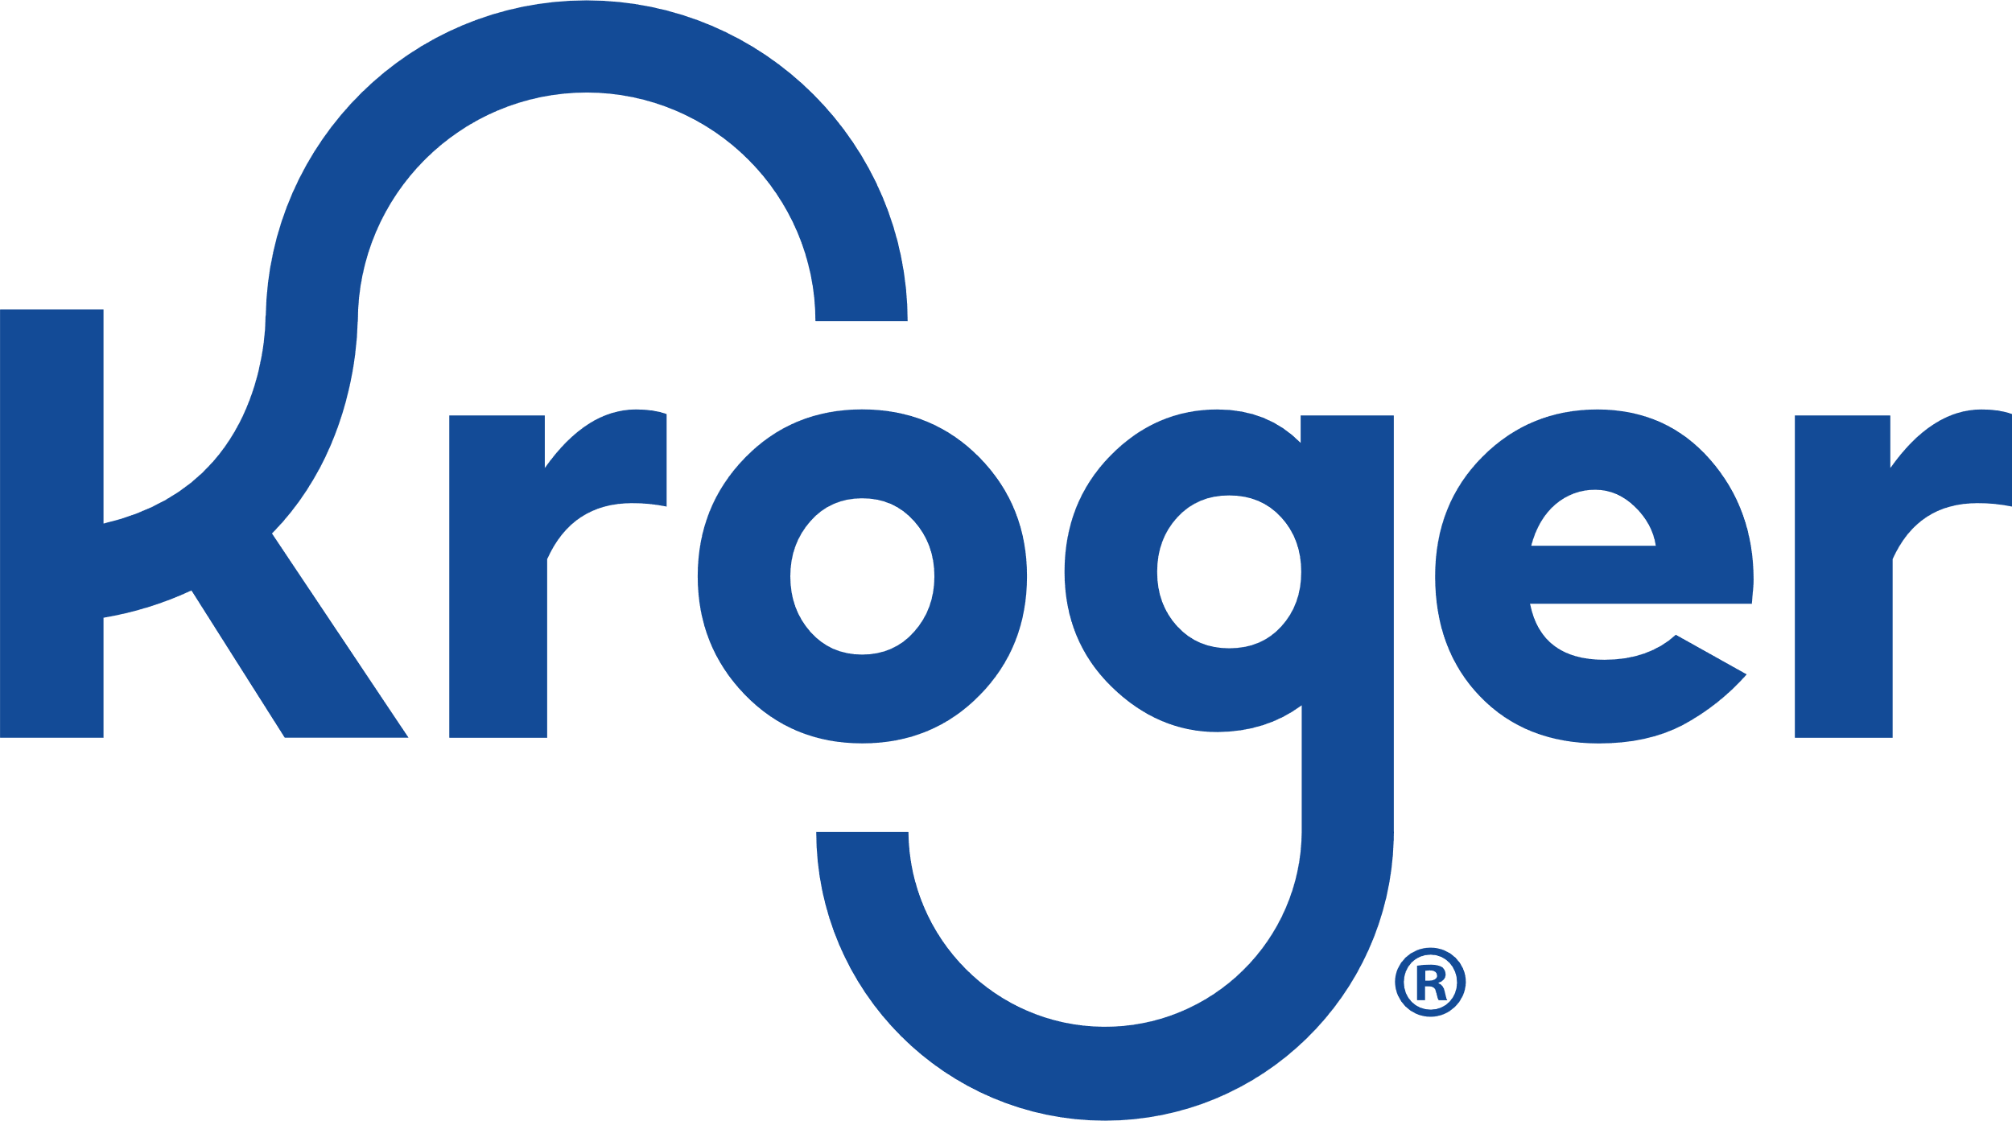
North Farmington Band & Orchestra Boosters
Kroger Community Rewards
Your everyday grocery shopping can earn the NFHS Band & Orchestra Boosters Community Rewards dollars -with no cost to you. It’s easy!
Simply link your Kroger Card to our community organization:
Go to Kroger.com and log into your account (you can create one if needed)
Once you’re logged in, you’ll see your name on the right side - you can access My Account from there.
On the left side you’ll see Community Rewards under your Dashboard. Click that and enter our Organization Number: QF946 It will show up as NORTH FARMINGTON H.S. BAND AND ORCHESTRA BOOSTERS.
That’s it! The Boosters typically earns $150 or so every quarter! That’s about what one clinician costs for a day.

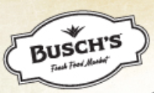
North Farmington Band & Orchestra
Boosters
Busch’s MyWay Cash for Education
Your everyday grocery shopping can earn your money for your student’s account with the NFHS Band & Orchestra Boosters -with no cost to you. It’s easy!
- Go to www.buschs.com/Myway and log in (or create) your account. Be sure to ‘Opt In’ to receive emails.
- In the dropdown menu beneath your name, select Cash for Education.
- Choose North F.H.S. Music Boosters as the organization you wish to support (you may support up to four organizations per quarter). Be sure to include your student’s name.
- You can enroll immediately. Enrollment for 2021 starts in October. You’ll need to re-enroll yearly.
- Encourage your neighbors and friends to enroll and include your student’s name. We’ll credit your student’s account each quarter when we receive the check.
- That’s it! Families can typically earn $20 or more per quarter.
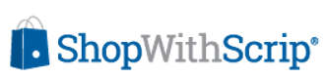
North Farmington Band &
Orchestra Boosters
ShopWithScrip is a convenient way to raise funds for your student’s account. You use gift cards to turn everyday shopping into earnings for your student’s music expenses.
- It's easy to get set up, and you can start earning today!
- Go to www.shopwithscrip.com and click on the blue 'Join a Program' button at the top right.
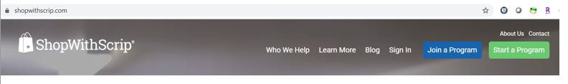
- You'll be asked to enter the NFHS Band & Orchestra Booster's Enrollment Code: ​DE8BB84B67648
- Fill out the rest of the forms, being sure to enter your student’s name and NFHS Band & Orchestra Boosters for the Classroom/Organization.
- Be sure to enroll in Online Payments (PrestoPay) -you’ll need to enter a credit card or bank account information. The Boosters does not collect checks for Scrip payments.
- Once your payment method is set up, you’re ready to start shopping. You can purchase E-gift cards to print at home and use immediately, or you can select physical gift cards which will be mailed in bulk to our Scrip Coordinator who will distribute them. There are also options to ‘reload’ physical gift cards.
  - For example, perhaps you need to purchase a new refrigerator. Home Depot’s reward is typically 4% (sometimes as much as 8%). Your refrigerator is going to be $500. You purchase a $500 e-gift card, print it online, go pick out your refrigerator and pay with that gift card. You’ve just earned $20 for your student’s account.
  - You can ShopWithScrip at places like CVS, Speedway, Meijers, Walmart, AutoZone, Staples, PetSmart, Burger King, Panera, etc.
- Invite your family and friends to ShopWithScrip for your student as well. Your student’s account will be credited monthly.
- If you have any questions, contact our Scrip Coordinator at scrip@nfhsmusic.org

- That’s it! Families have earned hundreds of dollars for their student’s account, which can be used for music travel, lessons, instruments, supplies and repair, Band Camp, concerts, or just about anything related to your student’s musical education.

