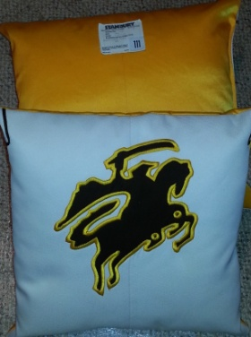
Limited Offering of Authentic
North Farmington HS Uniform
Pillows
All pillows feature the Raider on the white front with personalizing and Authentic Uniform Label on the Golden Yellow back. Make your choice fast - there is a limited supply of these available.
From the newest Freshman to the proud graduate, they will love to get one of these!
Make it special with your own personalized style. Add a name, date and or customize, the choice is yours!
Get your check made out to NFHS B.O.B. to the band room drop box in an envelope marked "pillow."
The first 125 ordered will have a piece of marching band history for their very own!
This offer is for a limited time. Seriously - this small quantity will go fast.
Expect a little extra time before delivery for the embroidery work. Pillow size is appx. 16 x 16.
Raider with no embroidery: $15 Raider with Embroidery: $21
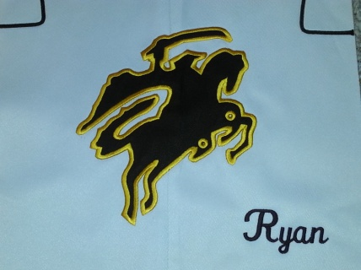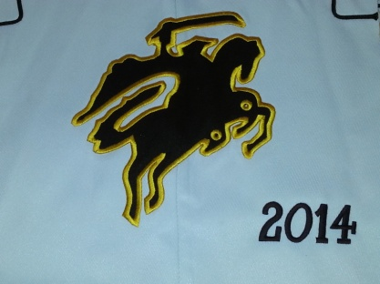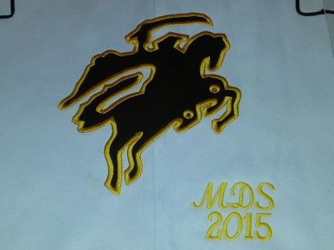
Name
Year
Initials with year

~~~~~~~~~~~~~~~~~~~~~~~~~~~~~~~~~~~~~~~~ tear here ~~~~~~~~~~~~~~~~~~~~~~~~~~~~~~~~~~
North Farmington HS Uniform Pillow
Contact Name____________________________ Phone: ______________________________
Name / Initials / Date ( PLEASE PRINT CLEARLY) | Quantity: | Thread Color Choice: | Charges:
Example: Ryan 2017 | 1 | Brown / Golden | $ 21
 |  | Brown / Golden | $
 |  | Brown / Golden | $
 |  | Brown / Golden | $
Raider with no embroidery: $15 Raider with Embroidery: $21
Total: |  |  | $

Check made out to: NFHS B.O.B. (Band and Orchestra Boosters)
Bring it to the band room drop box in an envelope marked "pillow."

